What Is a Nonprofit Performance Management System?
…And Why Does my Organization Need One?

How can our nonprofit report efficiently on all the data our funders want?
Our Board is demanding data on program effectiveness, so we can raise more funds! Where do we begin?
Whose job is it to gather, compile, and analyze the data? How do we make these decisions?

These common nonprofit pain points are symptoms of a deeper need to strengthen our performance management capacity. This refers to a set of practices that help nonprofits improve on their mission effectiveness. Before we can determine a reasonable data set to share with our Board or our funders, we first must come to agreement on a clear definition of organizational success.

We can understand a nonprofit’s mission by its clear response to these two questions:

- Who do we exist for? Whom do we directly influence? This is its target population, which may be individuals, organizations, or a whole community. A strong nonprofit focuses on a specific target population and knows its demographic characteristics, the strengths and assets participants bring, and the specific challenges they face to reach their goals. This is the reason why they need the nonprofit’s help.

- To what end do we engage them? To what result do we commit to them in our mission? For what are we accountable to the target population? Consider three different kinds of nonprofit mission accountabilities:
  - Some nonprofits provide for basic needs, for example a food pantry or the Red Cross.
  - Some nonprofits are accountable to deliver a specific quality service, for example universities, some health care organizations, some museums and arts organizations.
  - Some nonprofits help people (or organizations) achieve outcomes. Outcomes are changes in people’s lives, starting with initial outcomes (new knowledge, increased skills, changed attitudes or values), leading to intermediate outcomes (reach program milestones, changes in behavior), leading to long-term outcomes (change in condition or status), not more than one or two years after program completion.
All three kinds of missions are uniquely valuable to deliver public benefit. All three kinds of missions can be measured, and the nonprofit’s operation managed to improve performance on that metric. The point is for nonprofits to be clear and focused on their “who” and “to what end.”

For outcomes-driven nonprofits, organizational performance is ultimately defined as success in achieving intermediate and long-term participant outcomes.

A nonprofit performance management system enables an agency to answer these questions:
- What results or outcomes are we helping our participants accomplish?
- How well are we doing?
- With whom must we partner?
- How can we improve?

The goal of data analysis is to answer the question, How many of our target population (#1 below) reach long-term outcomes (#5 below)? And for the ones who did not reach the desired destination, Where did we lose them? How can we do better next time? Here are the essential data categories human services nonprofits can consider when designing their performance management systems:
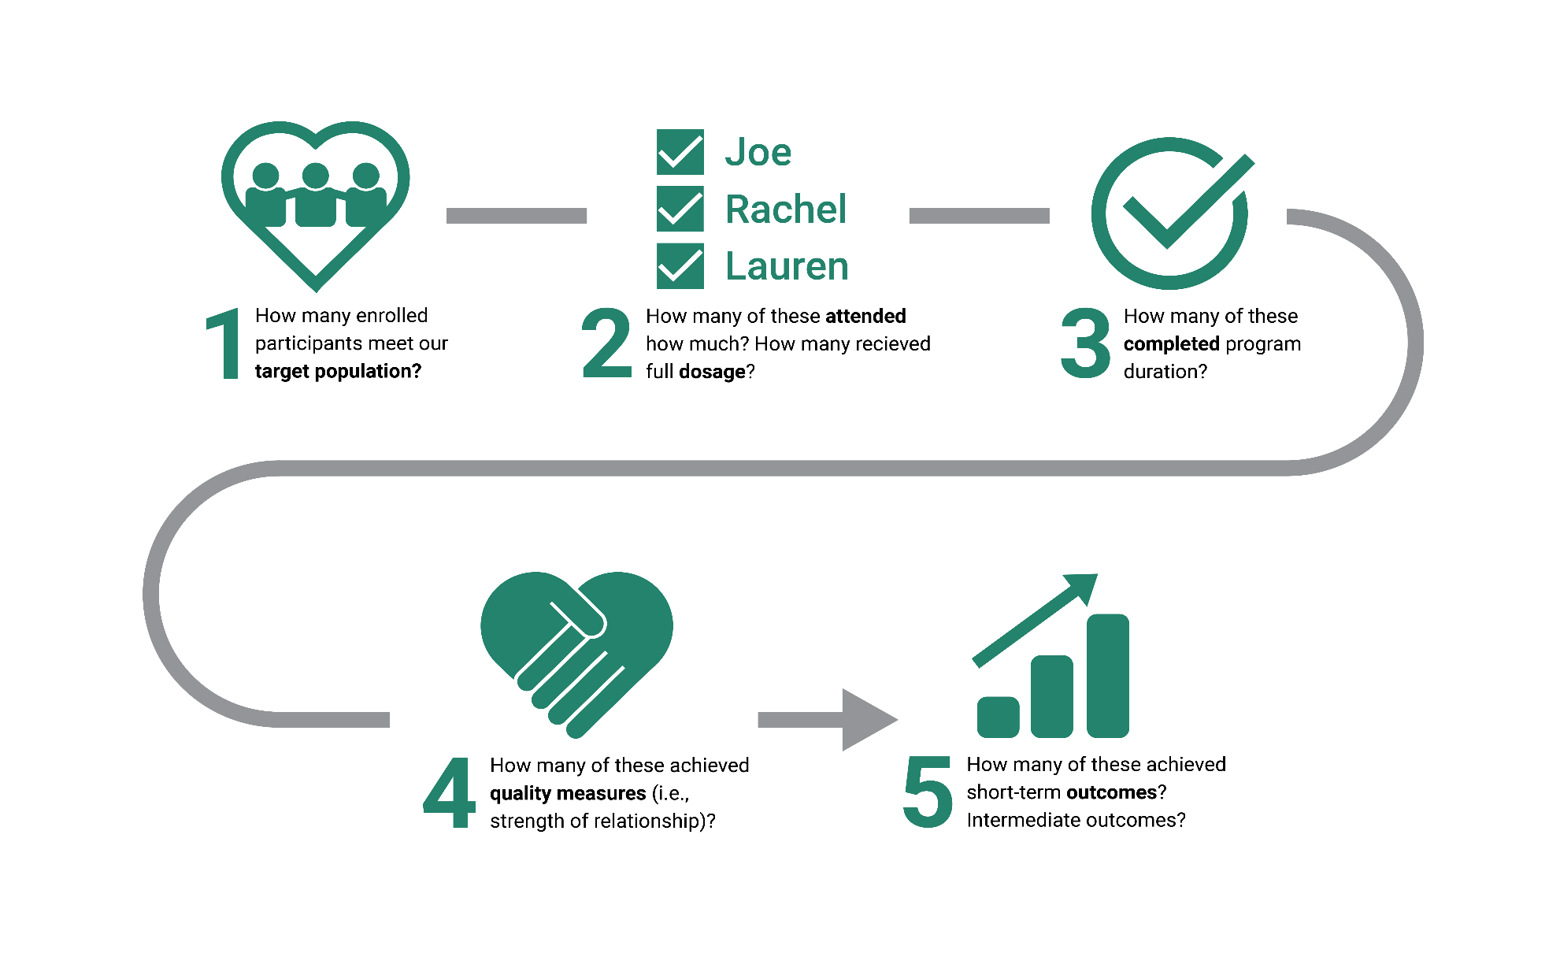
Once a nonprofit collects these key data sets, the next step is to analyze the data to learn how to strengthen the program to increase results. The organization can use this data to drive decision making -- about program improvement, about human resource management, about raising and allocating resources, and about strategic partnerships. This is an all-hands-on-deck, relentless pursuit of improving participant outcomes, which requires that a nonprofit make changes in the way it manages its operations. For many nonprofits, this shift represents significant culture change, requiring a 3 to 10 year transition. For this reason, we recommend engaging outside assistance to help your agency navigate building and implementing your performance management system.

How can a nonprofit prepare to strengthen these capacities? Scores of Boston nonprofits have built their performance management systems by following this road map of organizational commitments:
- Align with effective practice in the field
- Clarify mission and theory of change, including target population and outcome sequence
- Map logical program influence on outcomes, including necessary dosage and duration of activities
- Agree on specific outcome indicators for the target population
- Agree on accurate data sources and collection practices
- Build out database to hold, compile, and report on key data
- Align program performance with human resource management
- Align program performance with resource development functions
- Align program performance with strategic partnerships
These practices help nonprofits prepare to gather and analyze data to drive decision making for mission improvement.

The payoff for this investment is increased participant outcomes and mission effectiveness. The process leverages every other dollar and every other hour invested into your organization. Leap of Reason, by Mario Morino, provides a compelling case for the value of nonprofit performance management systems.

The Capacity Institute helps Boston area nonprofits build 17 performance management practices over two years. For more information, visit http://www.bmaboston.org/capacity-institute and contact Ellen Bass. Ellen is a member of the Leap Ambassadors, a national community of nonprofit thought leaders and practitioners who promote high performance in the nonprofit sector. The Capacity Institute’s practices are aligned with the Performance Imperative, the Leap Ambassadors’ seven practices of highly effective organizations.

